1st Floor
17 Baker Street
Rosebank
Johannesburg
South Africa
2196
Tel: +27 (0) 11 442 2434
Fax: +27 (0) 11 442 2454

ROACH 2 Chassis Thermal Analysis for everything on:
Following was used throughout unless change stated in scenario:

Inlet Pressure 0Pa Gauge
Inlet Temperature 25 Degrees Celsius
Outlet Pressure 0Pa Gauge

FPGA x1 40W
PowerPC x1 5W
ADC x2 1W
ROACH PHY x2 1W
ROACH PCB x1 1W
CPLD x1 0.3W
Flash x1 0.3W
RAMDIMM x1 4.4W
QDR x4 1.8W
Power Modules x3 2W
SFP PHY x4 2W
DDR2 x4 0.8W
1v0 x1 4W
Power Supply x1 1.2W

Scenario 1 FPGA 20W:
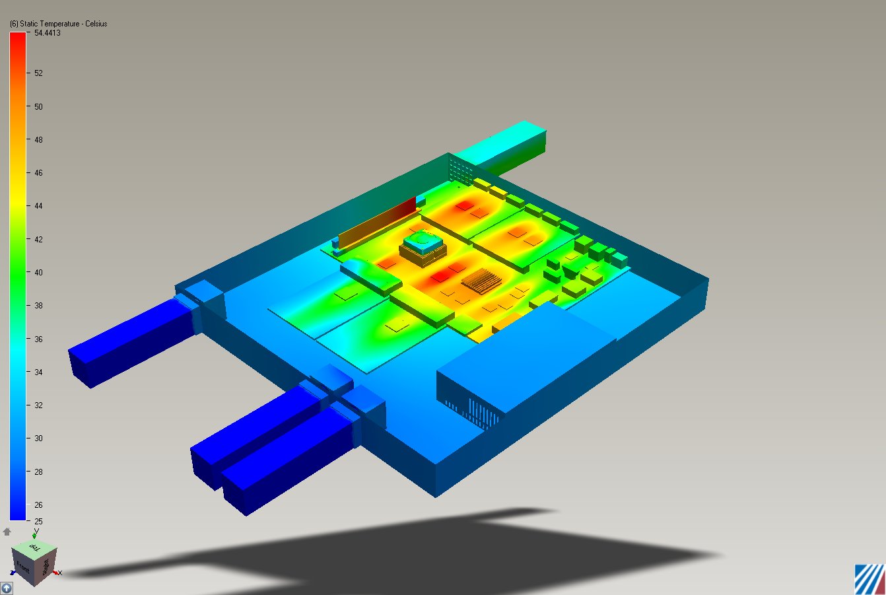

Scenario 2 FPGA 30W:
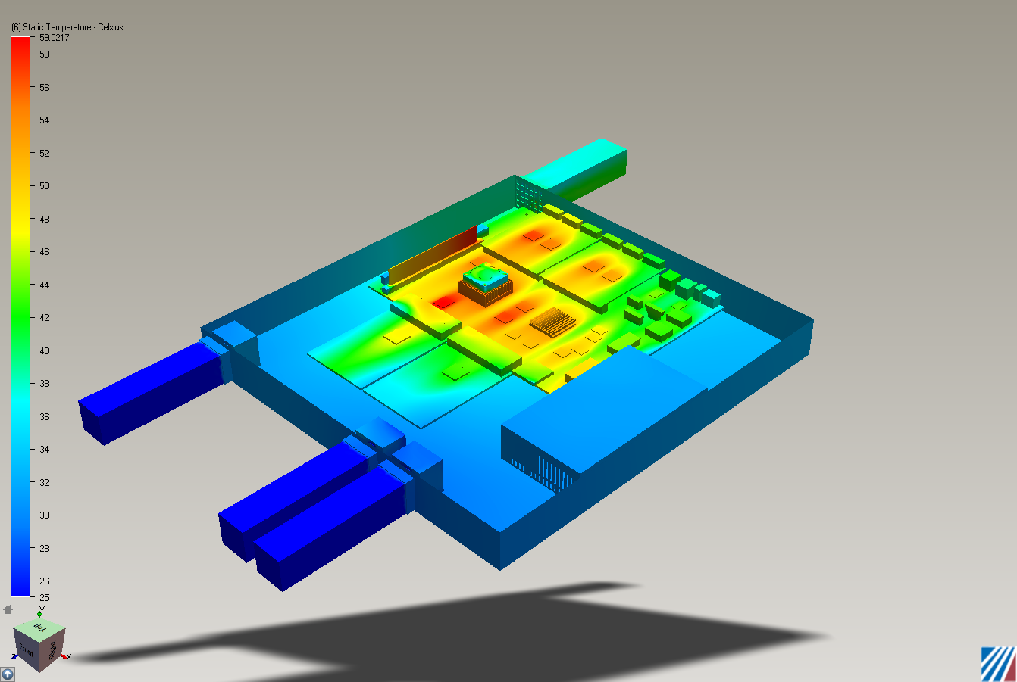

Scenario 3 FPGA 40W:
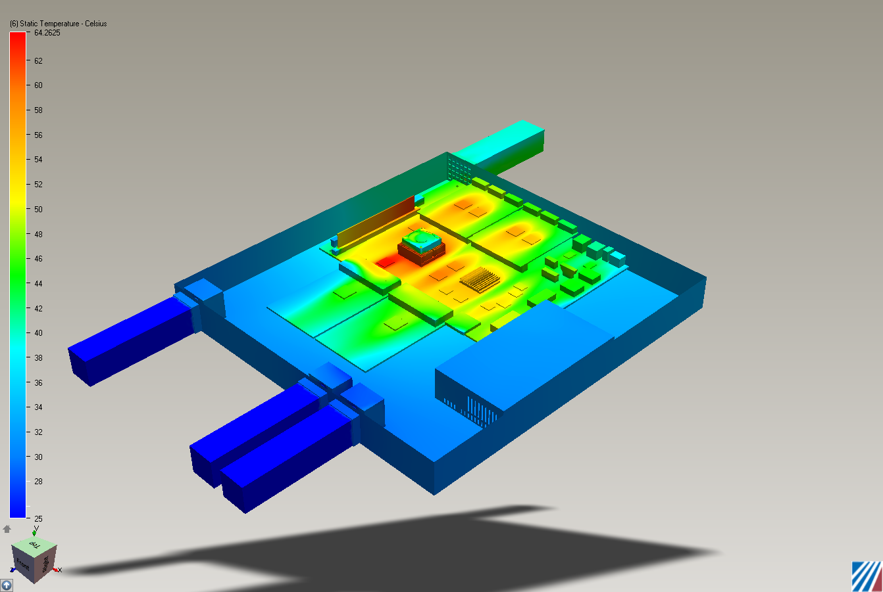

Conclusion:
The added heat from the SFP coupled with being forced to decrease the outlet sizing by manufacturing has resulted in the 40 degree scenario failing. Plan is to try and change the outlet back to previous size if AllFab can handle the tolerances.

